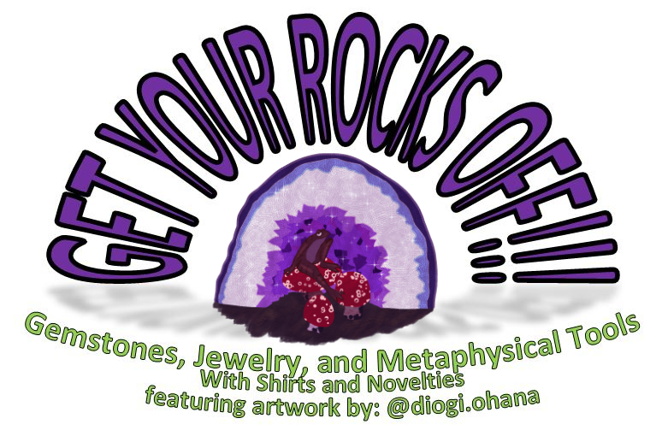
Turquoise, Mariposite, and Quartz (Smokey) Bracelet
$15

www.getyourrocksoff.shop
@getyourrocksoffshop
Jasper (Green), Amethyst, and Malachite Bracelet
$15

www.getyourrocksoff.shop
@getyourrocksoffshop
Sodalite, Magnesite, and Quartz Earring and Necklace Set
$28

www.getyourrocksoff.shop
@getyourrocksoffshop
Chakra Earring and Bracelet Set
$25

www.getyourrocksoff.shop @getyourrocksoffshop
Quartz (Rose), Amazonite, and Apatite Earring and Necklace Set
$28

www.getyourrocksoff.shop @getyourrocksoffshop
Chakra Anklet
$15

www.getyourrocksoff.shop @getyourrocksoffshop

Chakra
Referencing and healing the energy centers from the base of the spine to the top of the head. Each chakra point is associated with a specific color, and gemstones of that color can be used to activate or treat them. Chakra therapy vitalizes and influences the physical, emotional, mental, and spiritual movements of the mind and body.

Base – Garnet
Sacral – Carnelian
Solar Plexus – Tiger’s Eye
Heart – Malachite
Throat – Aquamarine
Third Eye – Jasper (Mookaite)
Crown – Amethyst
Onyx
Quartz

Quartz (Rose)
- Unconditional love and infinite peace
- Heart chakra stone that purifies and opens the heart on all levels
- Attracts love
- Draw off negative energy and replaces it with loving vibes
Amazonite
- Powerful filter
- Protects against electromagnetic pollution
- Combines intellect with intuition
- Brings emotional balance
- Fosters constructive expression of emotions
- Favorite stone of writers and musicians
Apatite
- Stone of inspiration and manifestation
- Develops psychic gifts and spiritual attunement, as well as deepens meditation
- Aids in communication and self-expression

Turquoise
- Efficient healer for solace of spirit and well-being of body
- Protective
- Spiritual attunement
- Enhances communication with physical and spiritual worlds
- Strengthens meridians
- Enhances physical and psychic immune systems
- (Tibetan Turquoise) Clears suppressed self-expression
- Chakra Point – Throat and Third Eye
Mariposite
- Helps in adapting to new situations
- Stress reducer and stabilizes energy
Quartz (Smokey)
- Most efficient grounding and anchoring stone
- Raises vibration during meditation
- Protective stone with strong link to earth and root chakra

Jasper (Green)
- “Supreme Nurturer”
- Releases obsession
- Chakra Point - Heart
Amethyst
- An extremely powerful and protective stone
- High spiritual vibration guarding against psychic attacks
- Blocks geopathic stress and negative environmental energies
- Enhances higher states of consciousness and meditation brining spiritual awareness
- Has a sobering effect on overindulgence, supporting sobriety
- Facilitates spiritual insight and common sense to decision making
Malachite
- *Do NOT ingest or soak in liquid – cleanse with quartz after each use*
- Chakra Point – Throat
- Amplifies positive and negative energy
- Grounds spiritual energy onto the planet
- Absorbs negative energy and pollution
- Transformation stone
- Deep emotional healing

Sodalite
- Unites logic with intuition and opens spiritual perception
- Stimulates pineal gland
- Clears electromagnetic pollution
Magnesite
- Deep peace to meditation and relaxation
- Enhances visualization and imagery
- Unconditional love, including self-love and love for difficult people due to behavior or addiction
- Calming effect to emotions, promoting tolerance for emotional stress
- Chakra Point – Throat and Heart
Quartz
- “Master Healer” – Can be used for any condition
- Most powerful healing and energy amplifier
- Raises energy to highest possible level

Chakra
Referencing and healing the energy centers from the base of the spine to the top of the head. Each chakra point is associated with a specific color, and gemstones of that color can be used to activate or treat them. Chakra therapy vitalizes and influences the physical, emotional, mental, and spiritual movements of the mind and body.

Base – Red Agate
Sacral – Citrine
Solar Plexus – White Shell
Heart – Green Apatite
Throat – Aquamarine
Third Eye/Crown – Amethyst
Quartz

